Learning WeApp Day 1 Instructions

Step 1: Download the Wechat Devtools

The first thing you need to do before you start learning how to develop a wechat mini-app is to download the Wechat Devtools. You can find the download link from here:

<https://developers.weixin.qq.com/miniprogram/en/dev/devtools/devtools.html>

Follow the instructions and get it installed on your computer.

Step 2: Import the project

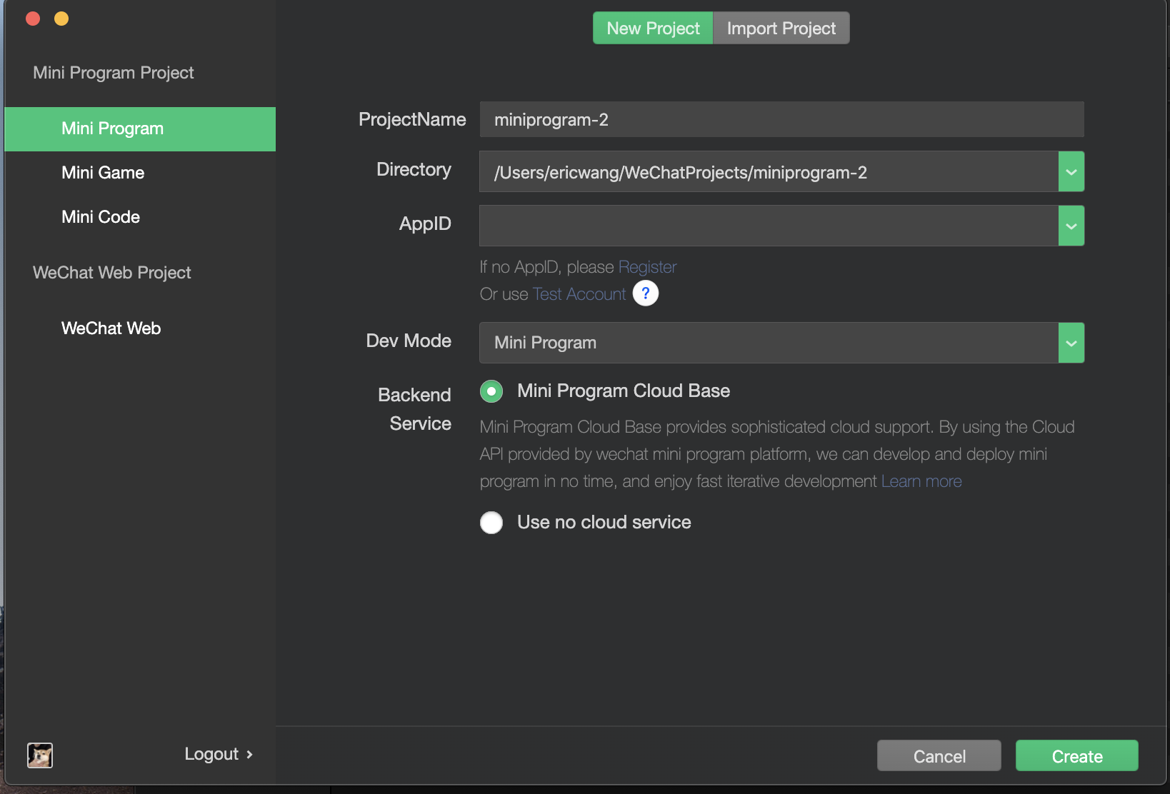Once you installed the Wechat Devtools, you will find a folder named “Day 1” in the same folder as this file. To import that folder to the Wechat Devtools, you will need to select “Mini Program” on the left column and click on the “Import Project”. Select the path of the ENTIRE folder before you import the file. In our case you will need to select the folder “Day 1”

Step 3:

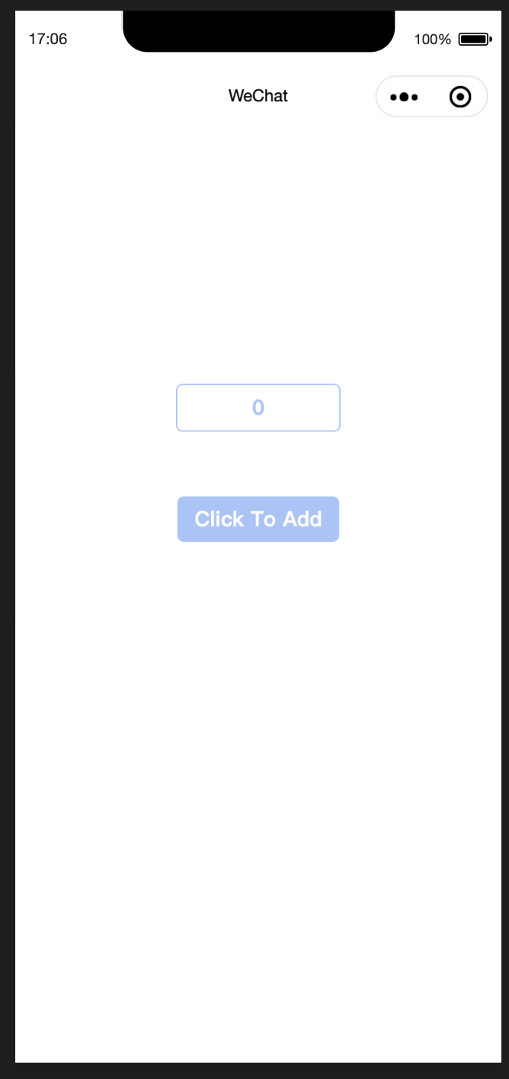Once you import the file, you will see the following screen if you open the simulator.

Try to add a function and edit the files called “/pages/index/index.js” and “/pages/index/index.wxml” so that you will make the box “Click To Add” into a button. Each time you click on the button, the number in the box above will add one to itself.